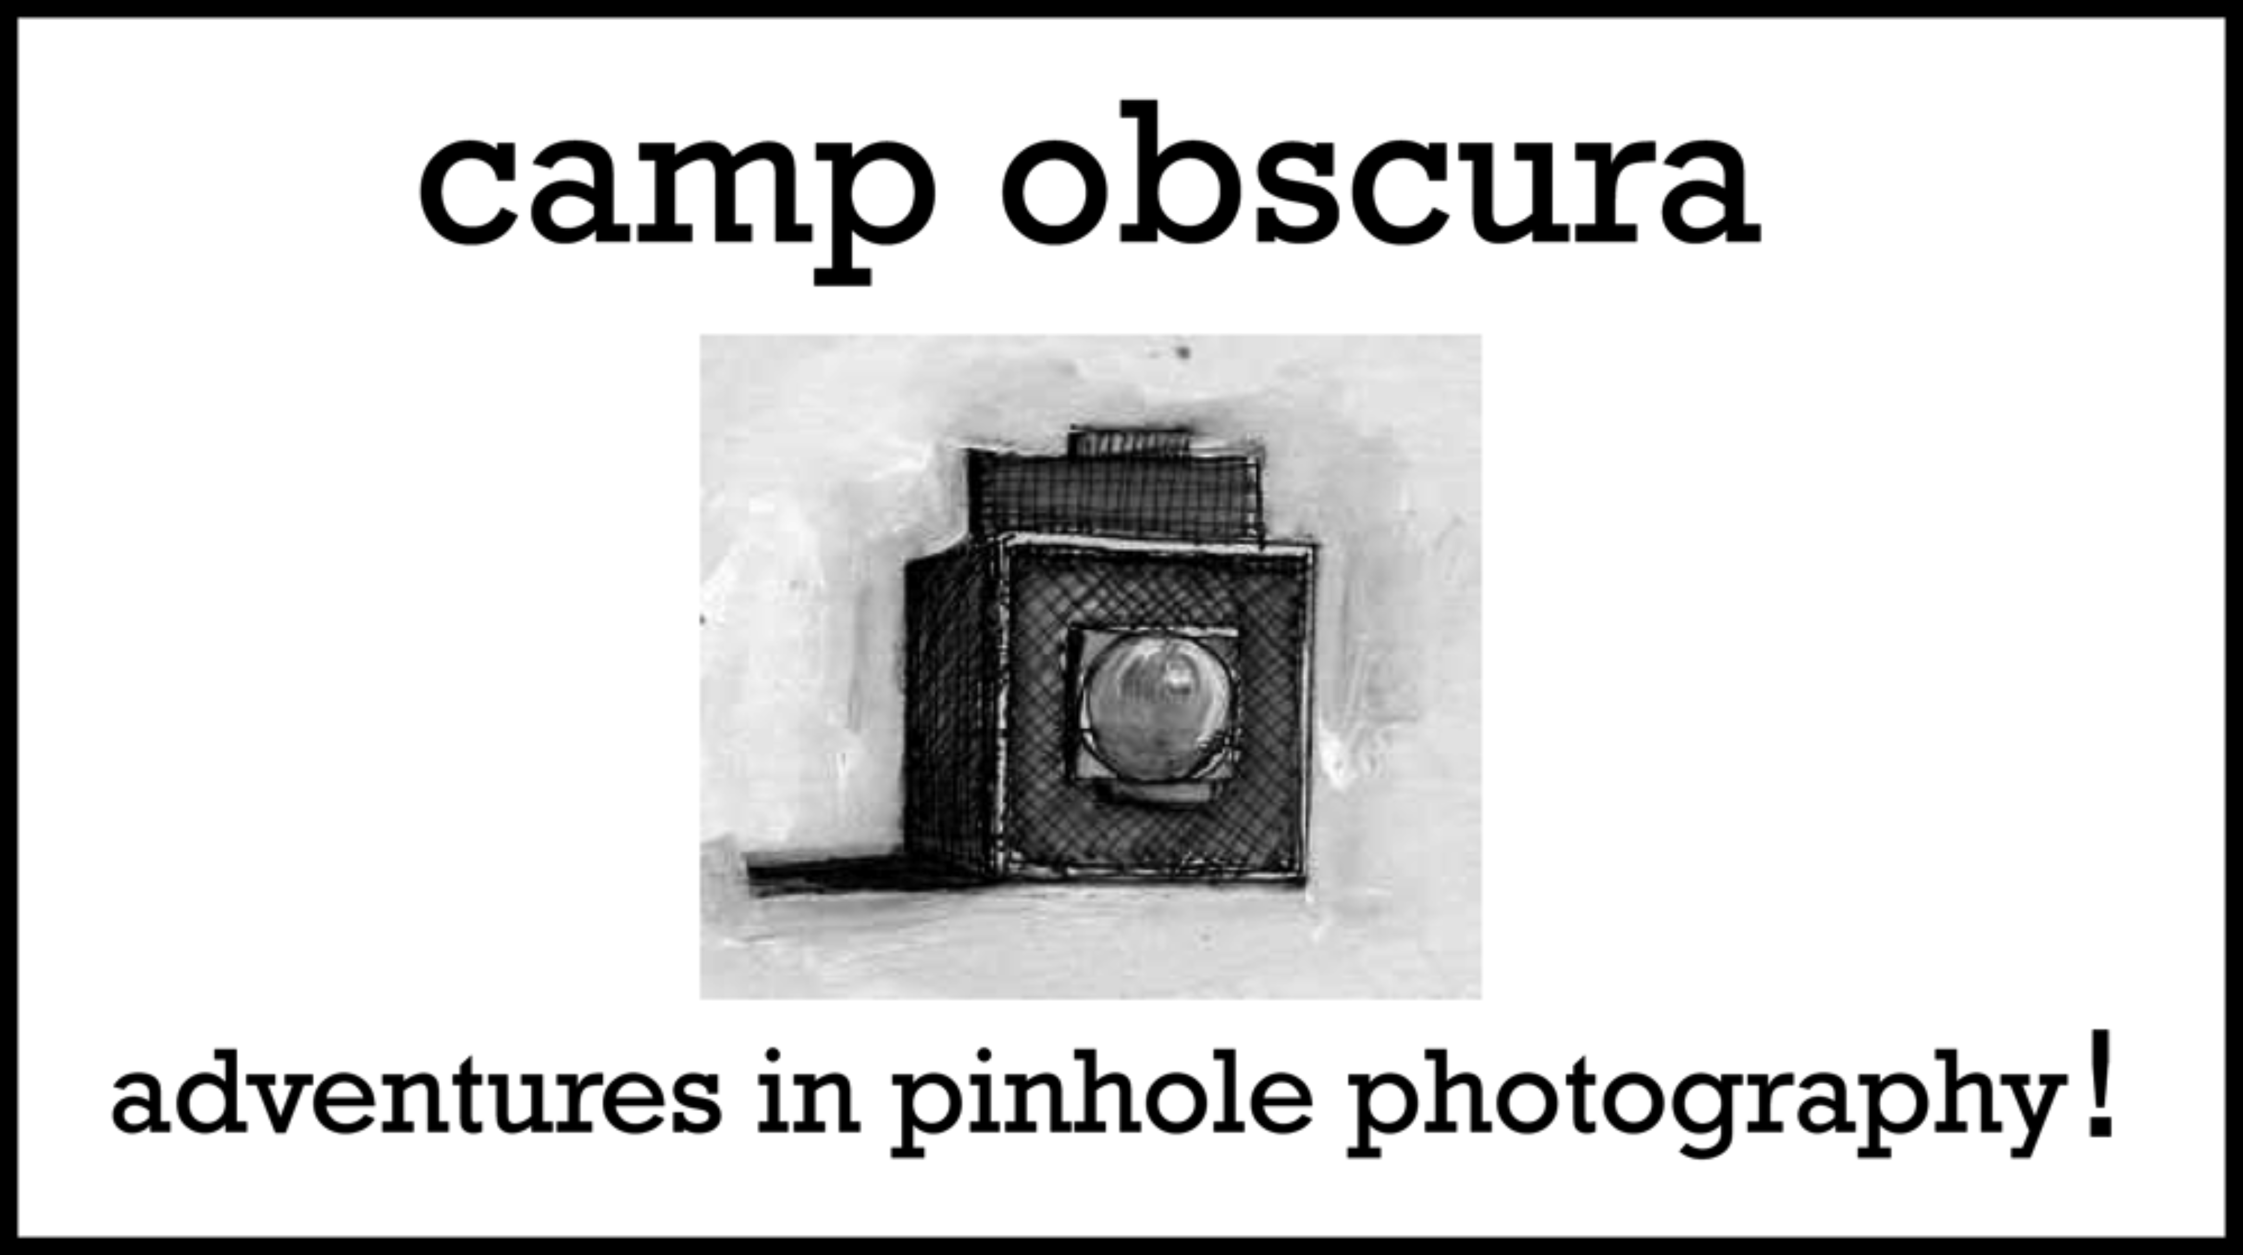

Camera Obscura Preliminary Lesson Plan

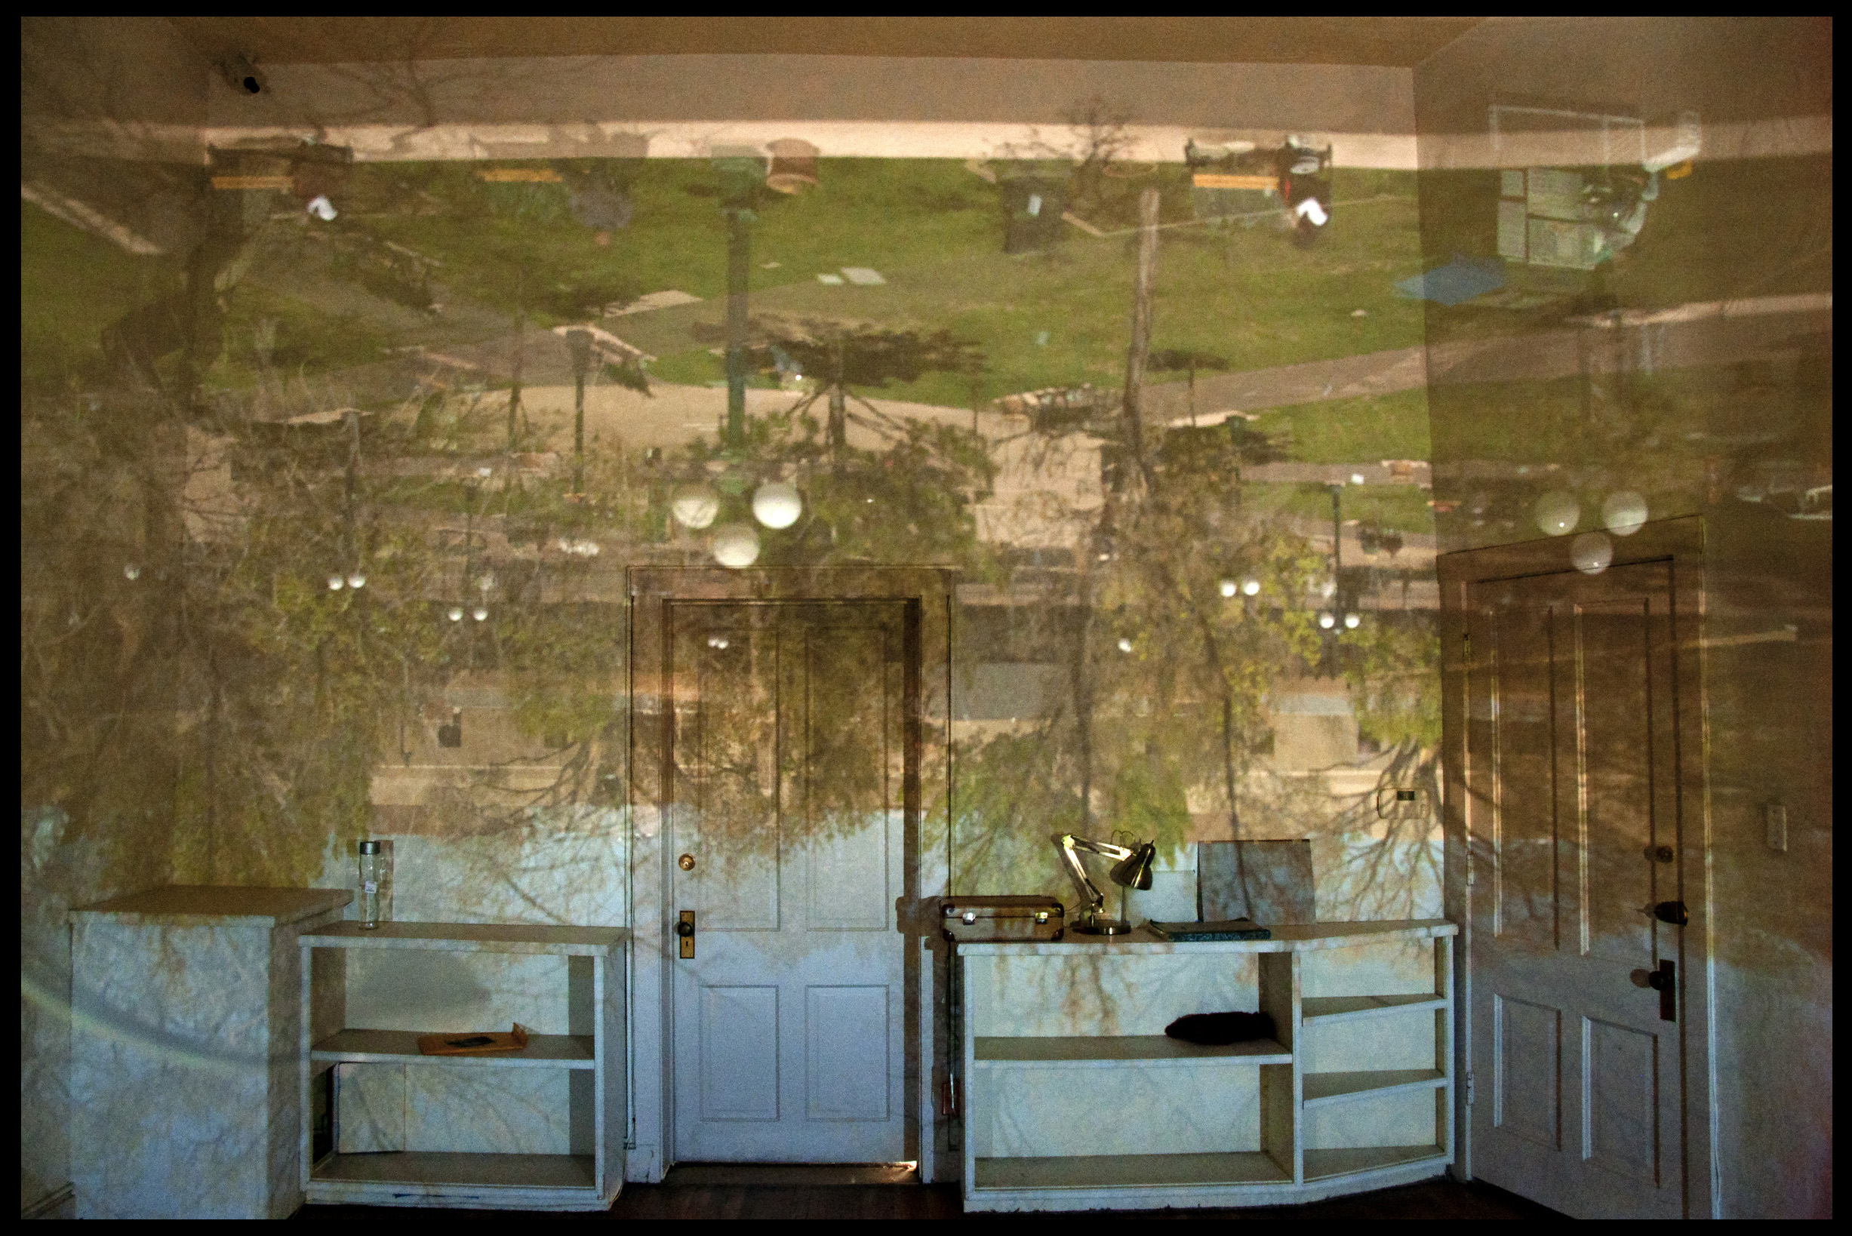

Latin for “darkened chamber”, camera obscuras have fascinated people since 500 B.C. Although their popularity faded with the dawn of technology, they still have much to offer. While inside students will experience first hand the way light moves and images are revealed, concepts that are at the core of photography - from its beginnings up to the most modern cameras used today. Taking time to discuss how math, science, history, art and our bodies all apply to the camera obscura offers a lesson that blends well in schools through the STEM program. While appropriate for any age, this particular plan is directed toward 4th through 6th grade. Adjustments to quiz and activities can be made accordingly.

This is a two-day program.

1. Set up a camera obscura in a convenient location.
2. Invite students inside.
3. Follow up with a slide show (if digital cameras are available) and a short quiz. Students make their own apertures and are given instructions provided below for creating a camera obscura at home.

1) Prep - Creating a Camera Obscura

Requirements and Supplies:

An appropriate space that can be easily darkened is necessary. The room should not be too large and it must have a window where the sun does not shine directly onto the aperture. White or light colored walls inside are needed for the image to show up. An active and bright view out the window is best.

Black Plastic, 6 ml.

Painters Tape

Ladder

Black Board and Large Hole punches for making apertures.

(The size of aperture/hole punch depends upon the size of room, any where from ½ inch to 1-½ inches is likely).

Two sizes of apertures are helpful to demonstrate how the amount of light and focus are affected, or even to offer an alternate view.

Additional items for activities may include:

Mirrors

Prisms

White Poster Board

Paper and Pencil

Digital Cameras and Tripods if possible

Choose your point of view/s and tape your aperture/s to the inside of the window flat against the glass.

From the inside, cover all openings where light may shine through with black plastic, except for your aperture/s. Use painters tape as to not damage your walls. Be sure to secure the plastic with tape around the edges of the aperture. A small flap of black plastic can be used as a cover for the opening if needed.

2) Day One - The Experience

When viewing, I find it beneficial to start with a darkened room to let the eyes adjust before opening the aperture. After a discussion and question/answer period, students are encouraged to play. They can use white poster board, holding it up closer to the image source and at different angles to it, even bending the board to distort the image. At this time mirrors and prisms can be introduced for experimentation. If the image lacks action…some of the students can go outside and become part of the image, switching places at some point. When possible, cover the walls with white paper and let the students draw the perspective they see.

Wrap up the event with image making inside the camera obscura if digital cameras are available. Their low light capabilities work well and you may be surprised how much the camera sees that your eyes may not.

1. Day Two - Follow Up

If possible, a follow up class is highly recommended. So many different topics can be discussed inside the camera obscura that revisiting them again can be very beneficial. I would start by bringing supplies for students to make apertures and giving them instructions for creating a camera obscura at home. Sketches that were done can be displayed and if digital cameras were available, a slide show is a must.

This short quiz can be given in groups of 4 or 5, giving students a chance to discuss options. While on the field trip, be sure to touch on all of the topics that are included in the quiz.

Camera Obscura Quiz

1) What is an aperture?

2) What 2 things are affected by changing the size of the aperture?

3) What part of the body can the camera obscura be related too and why?

4) Explain why the image projected is upside down and backwards.

5) Name two ways a camera obscura has been used in history.

Answer Key

1. An opening for light to enter.
2. The amount of light and the focus
3. The eye, being inside a camera obscura can be likened to being inside of an eyeball, the pupil is similar to the aperture, and the retina becomes the walls of the room. Explain how the optic nerve carries the information to our brains, which flips the image like a mirror in a camera.
4. Light moves in a straight line. We see reflected light, it bounces off the objects and in a direct path with the aperture the image enters the camera obscura. Clouds in the sky will project onto the floor, objects on the left reflect on the right, etc.
5. A few examples:

\*Art, the camera obscura was used to aid in perspective drawing in addition to advancing the discovery of photography.

\*Modern optics; eyeglasses, telescopes, lens etc. were created with the use of a camera obscura for experimenting.

\* A form of early surveillance, Nomads in the African desert would install apertures in their tents. When stopping to rest in the heat of the day they could watch for enemies approaching with their tent transformed into a camera obscura.

\*Entertainment, in the pre film era camera obscura was used as a cinematic experience. Small wooden huts used as camera obscuras were built along the shores of Northeastern United States, their charm did not wane until the advent of color film.

Resources:

New Mexico History Museum, Photo Archives

“Pinhole Photography” by Eric Renner

“The Book of Alternative Photography”, by Christopher James

“Camera Obscura”, by Abelardo Morell

www.campobscura.com